Week 9: Sales and Customer Analytics System
The e-commerce company wants to analyze its sales data to understand customer purchasing behavior, product performance, and revenue trends. The management team needs reports to identify top customers, best-selling products, and profitable categories.

- Total number of orders placed.
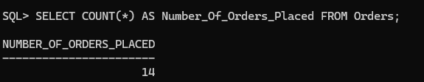
- Total revenue generated from sales.
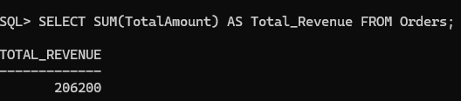
- Average order value.
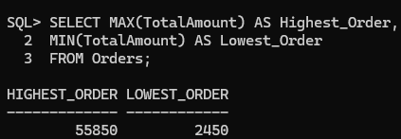
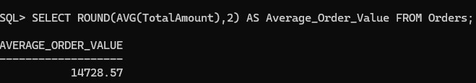

- Highest and lowest order amount.

Total sales for a specific period.
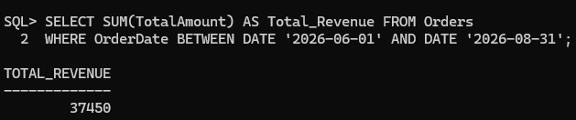

Customer Purchase Analysis
- Total number of orders placed by each customer.
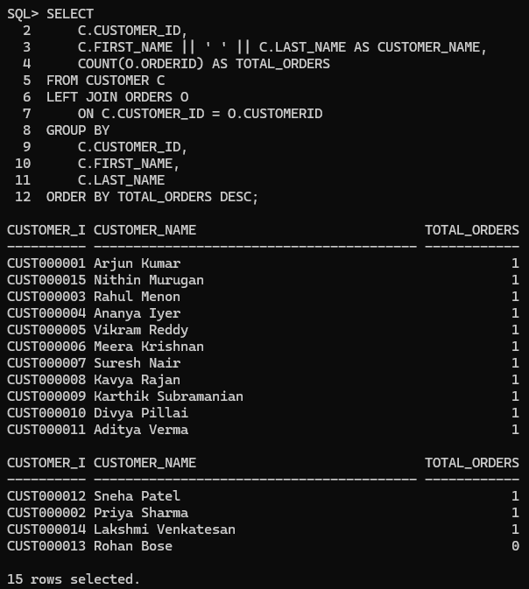

- Total amount spent by each customer.
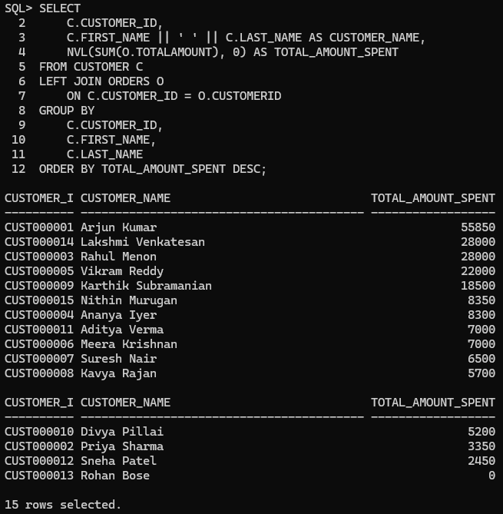
- Average spending per customer.

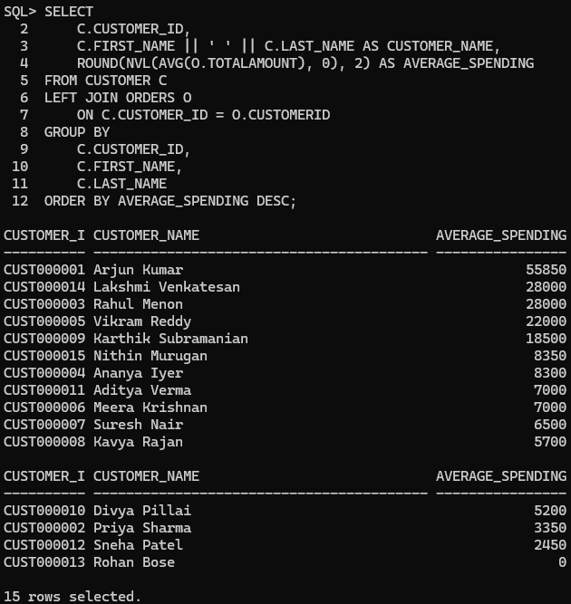

- Customers with maximum purchase amount.
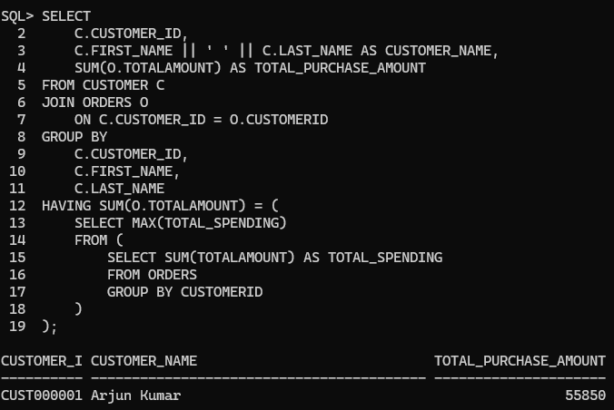
- Customers with fewer purchases.

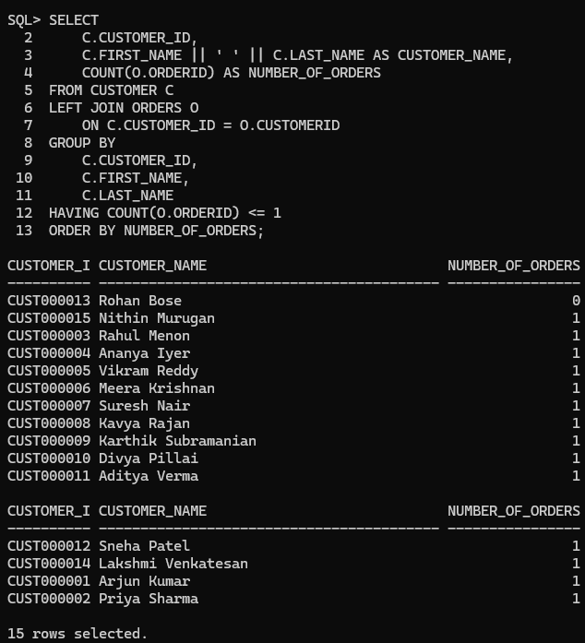

Find Top Customers Based on Purchase Amount
- Top 5 customers based on total spending.
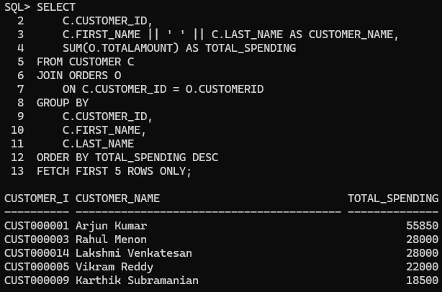

- Customers with maximum number of orders.
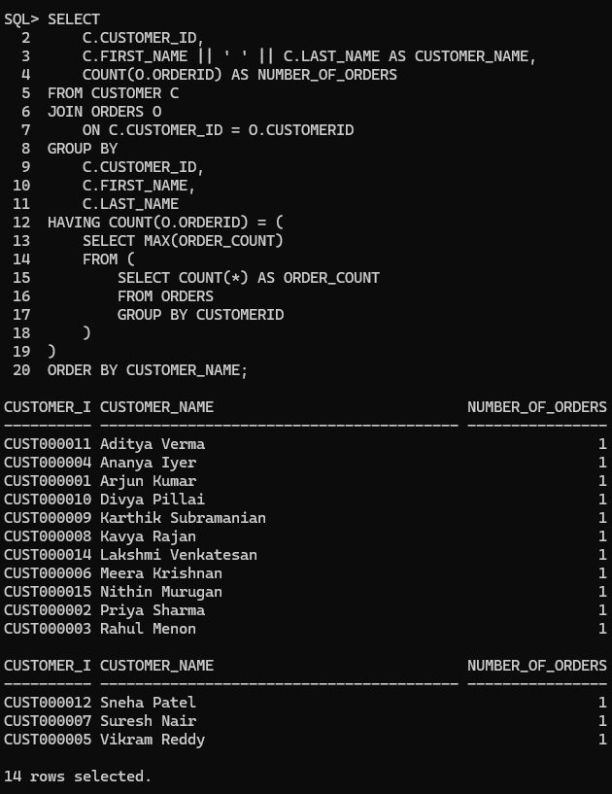
- Frequent customers.

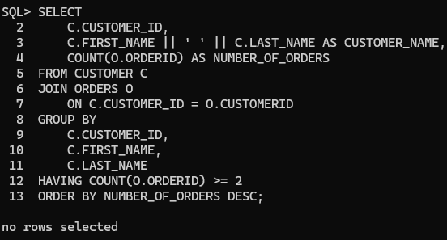
- High-value customers.
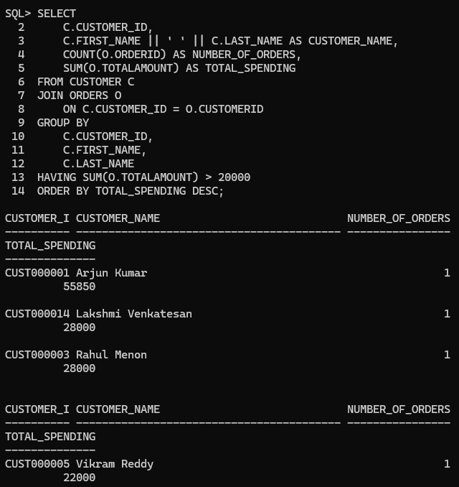

Identify Best-Selling Products
- Products with maximum sales quantity.
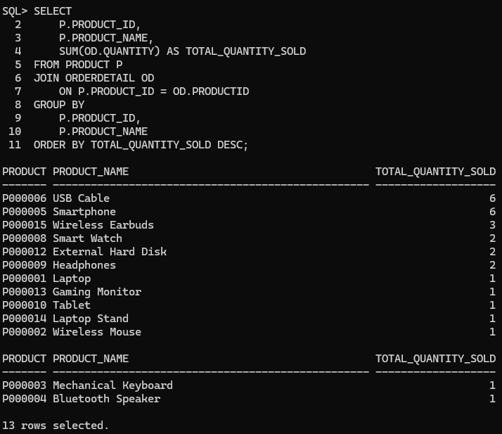
- Products generating highest revenue.
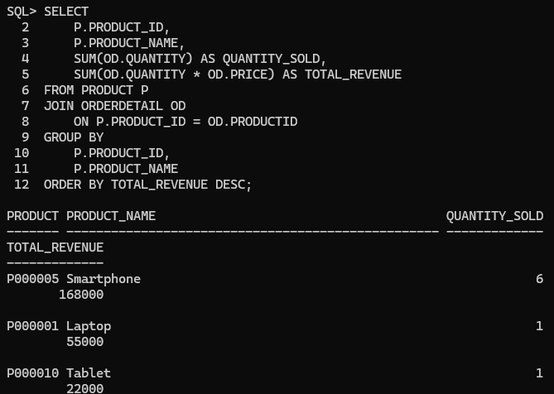

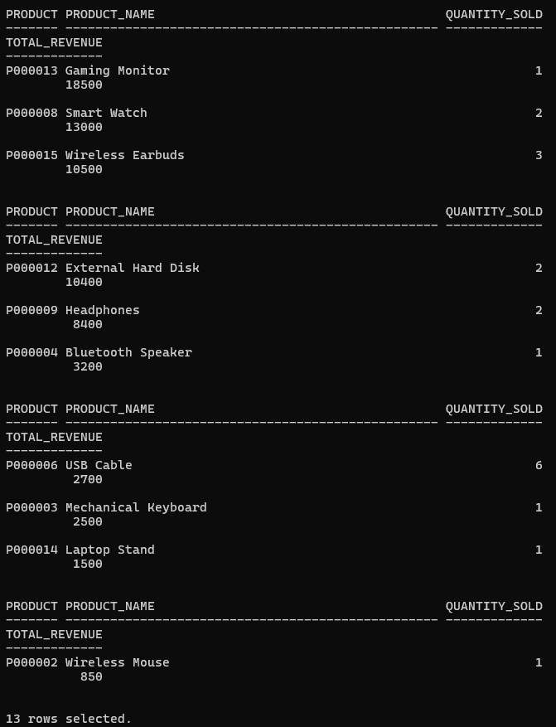

- Least-selling products.
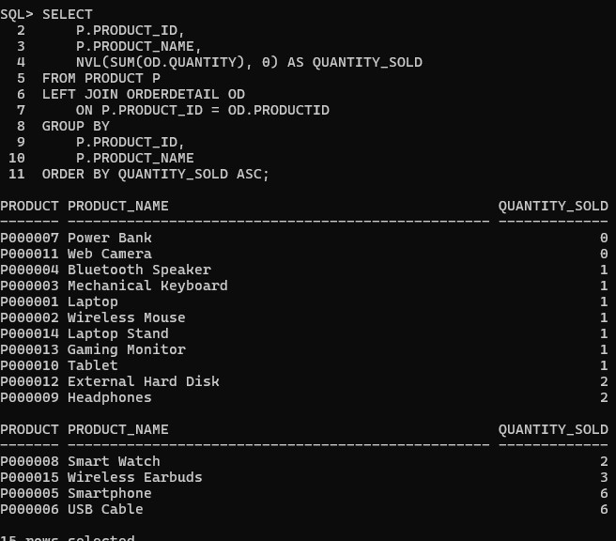

- Products requiring promotion.
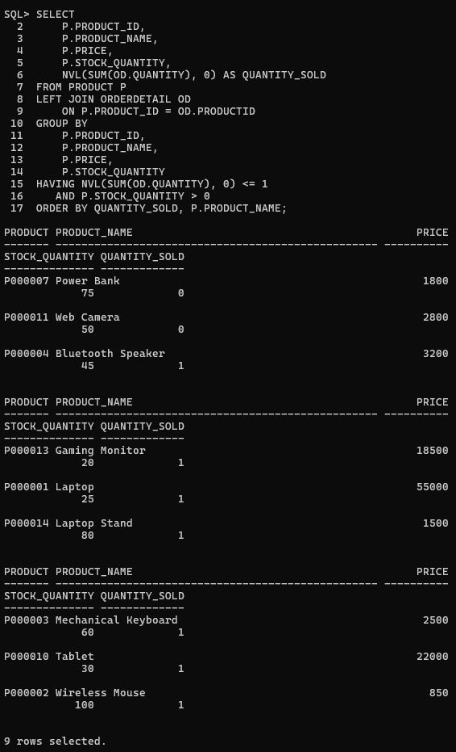

Perform Category-wise Sales Analysis
- Total sales generated by each category.
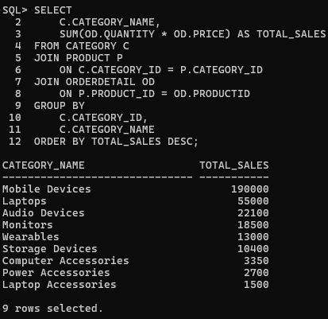
- Number of products sold in each category.
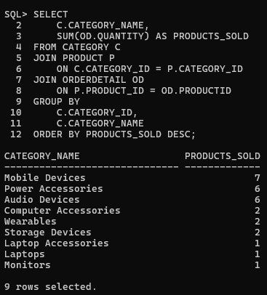

- Highest revenue-generating category.
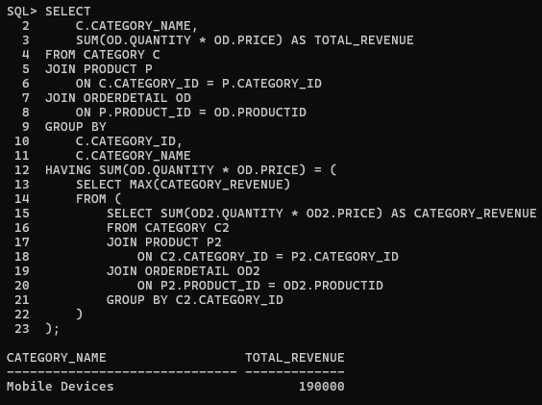
- Average sales per category.
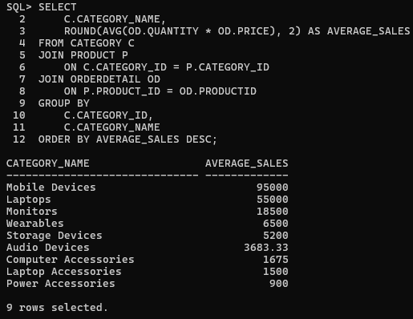

Generate Business Analytics Reports Report 1: Sales Performance Report
  - Total sales
  - Number of orders
  - Average order value

Highest order value
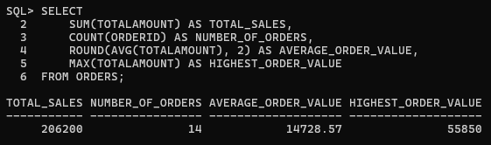

Report 2: Customer Analytics Report
  - Customer name
  - Number of orders
  - Total spending
  - Purchase frequency
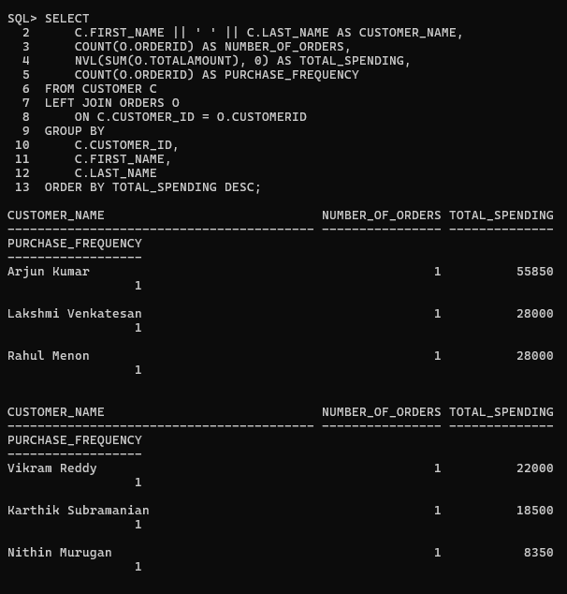

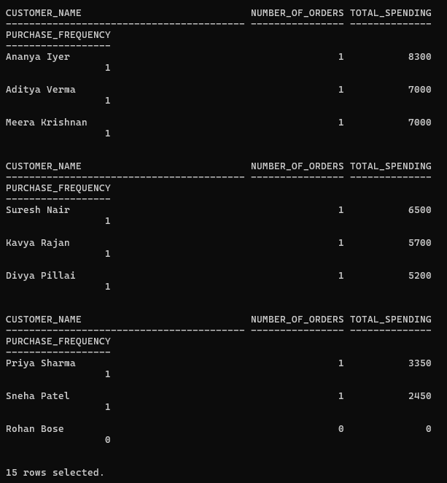

Report 3: Product Performance Report
  - Product name
  - Quantity sold
  - Revenue generated
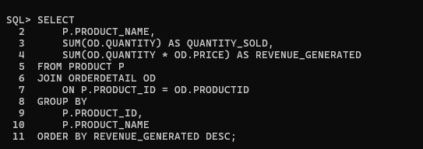

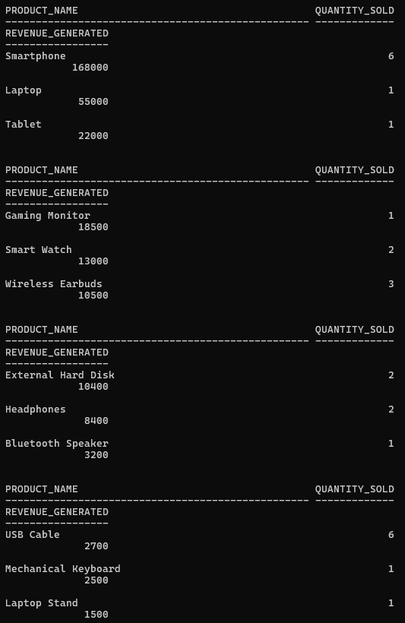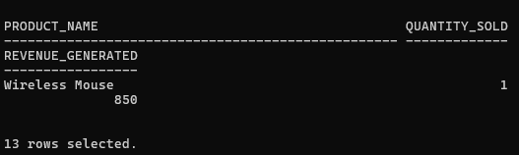

Report 4: Category Analysis Report
  - Category name
  - Total products sold
  - Total revenue


